PRACTICE TASK CLASS -10
MEMORY UTILISATION COMMANDS

- disk usage (du) and disk free (df)
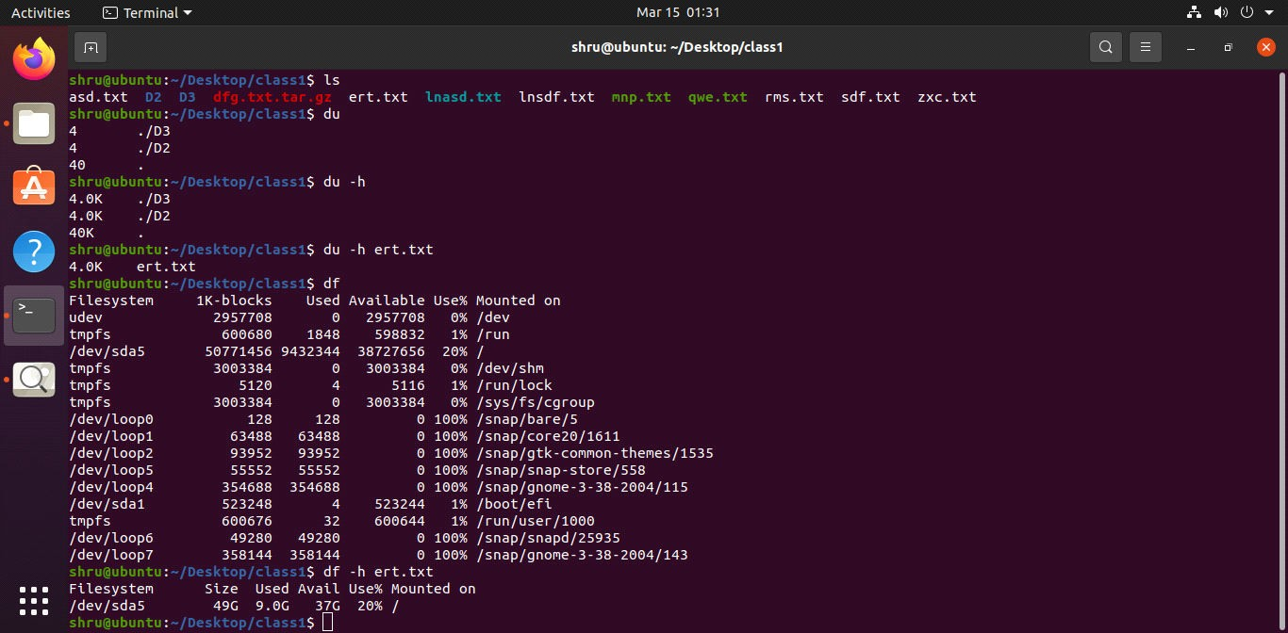
- top command
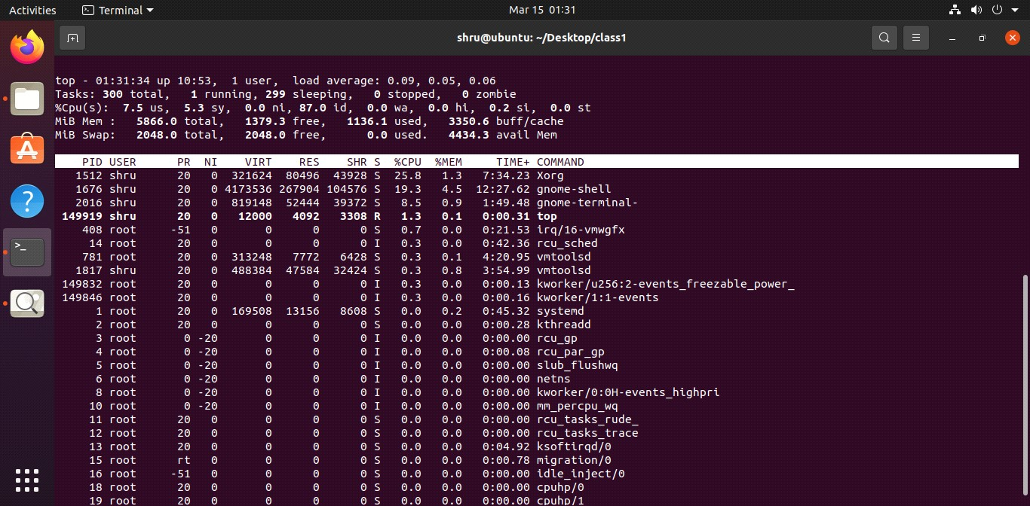
- ps command

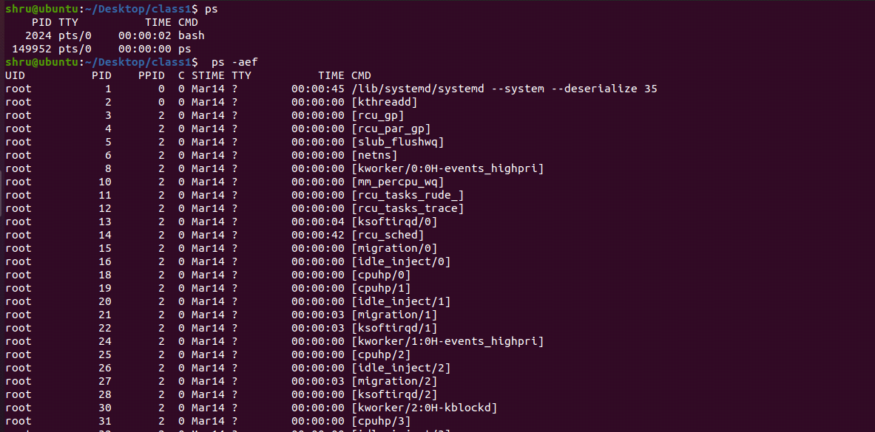

NETWORK COMMANDS

- ping command
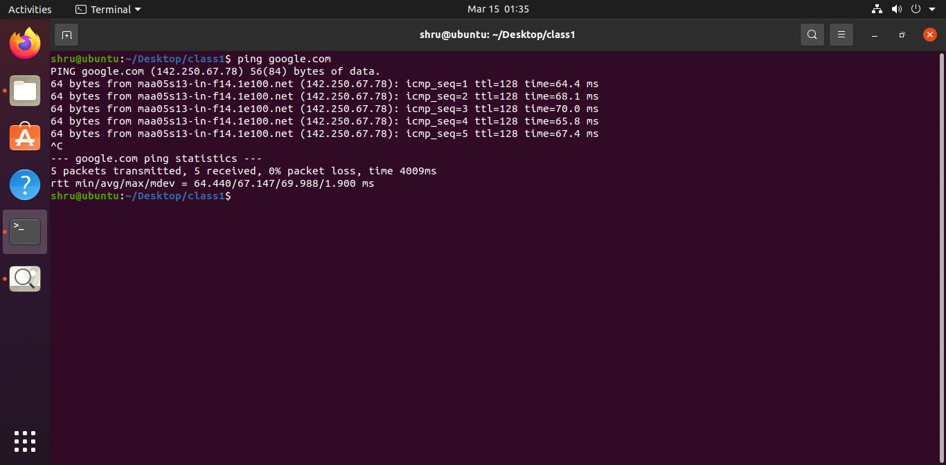
- telnet command
